CALCULATOR WITH SWITCH STATEMENT

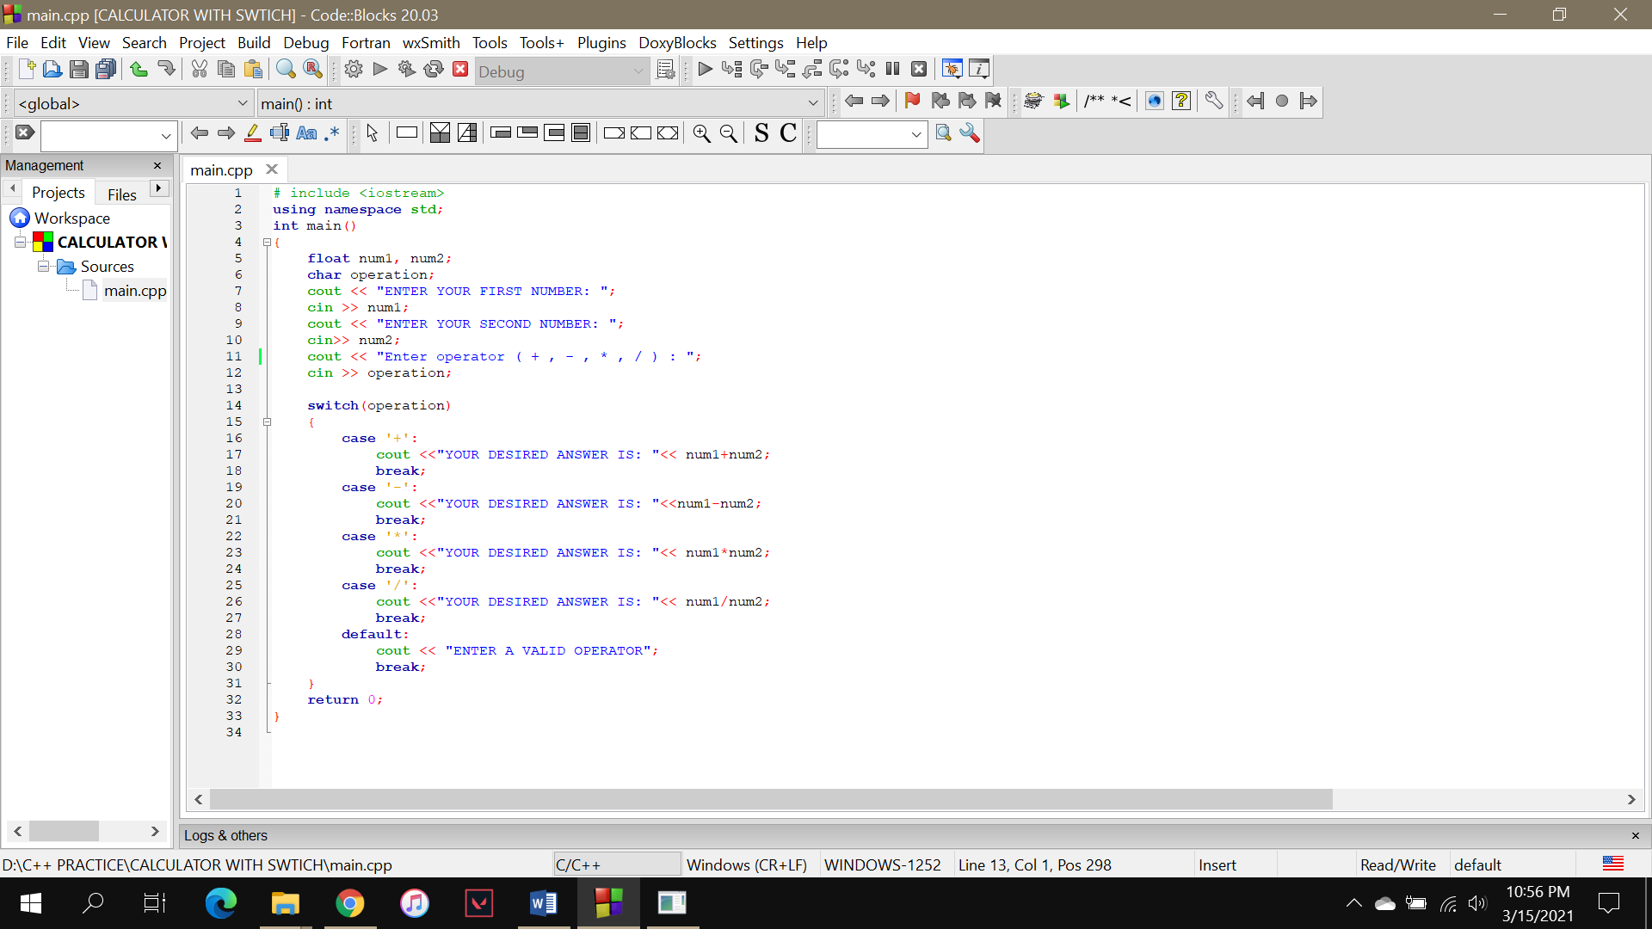

OUTPUT (+)

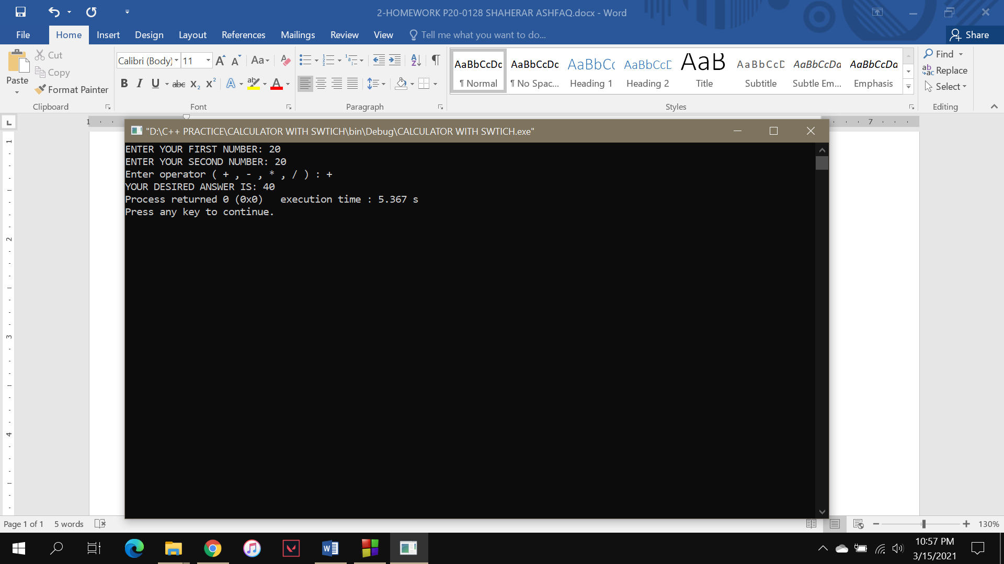

OUTPUT (-)

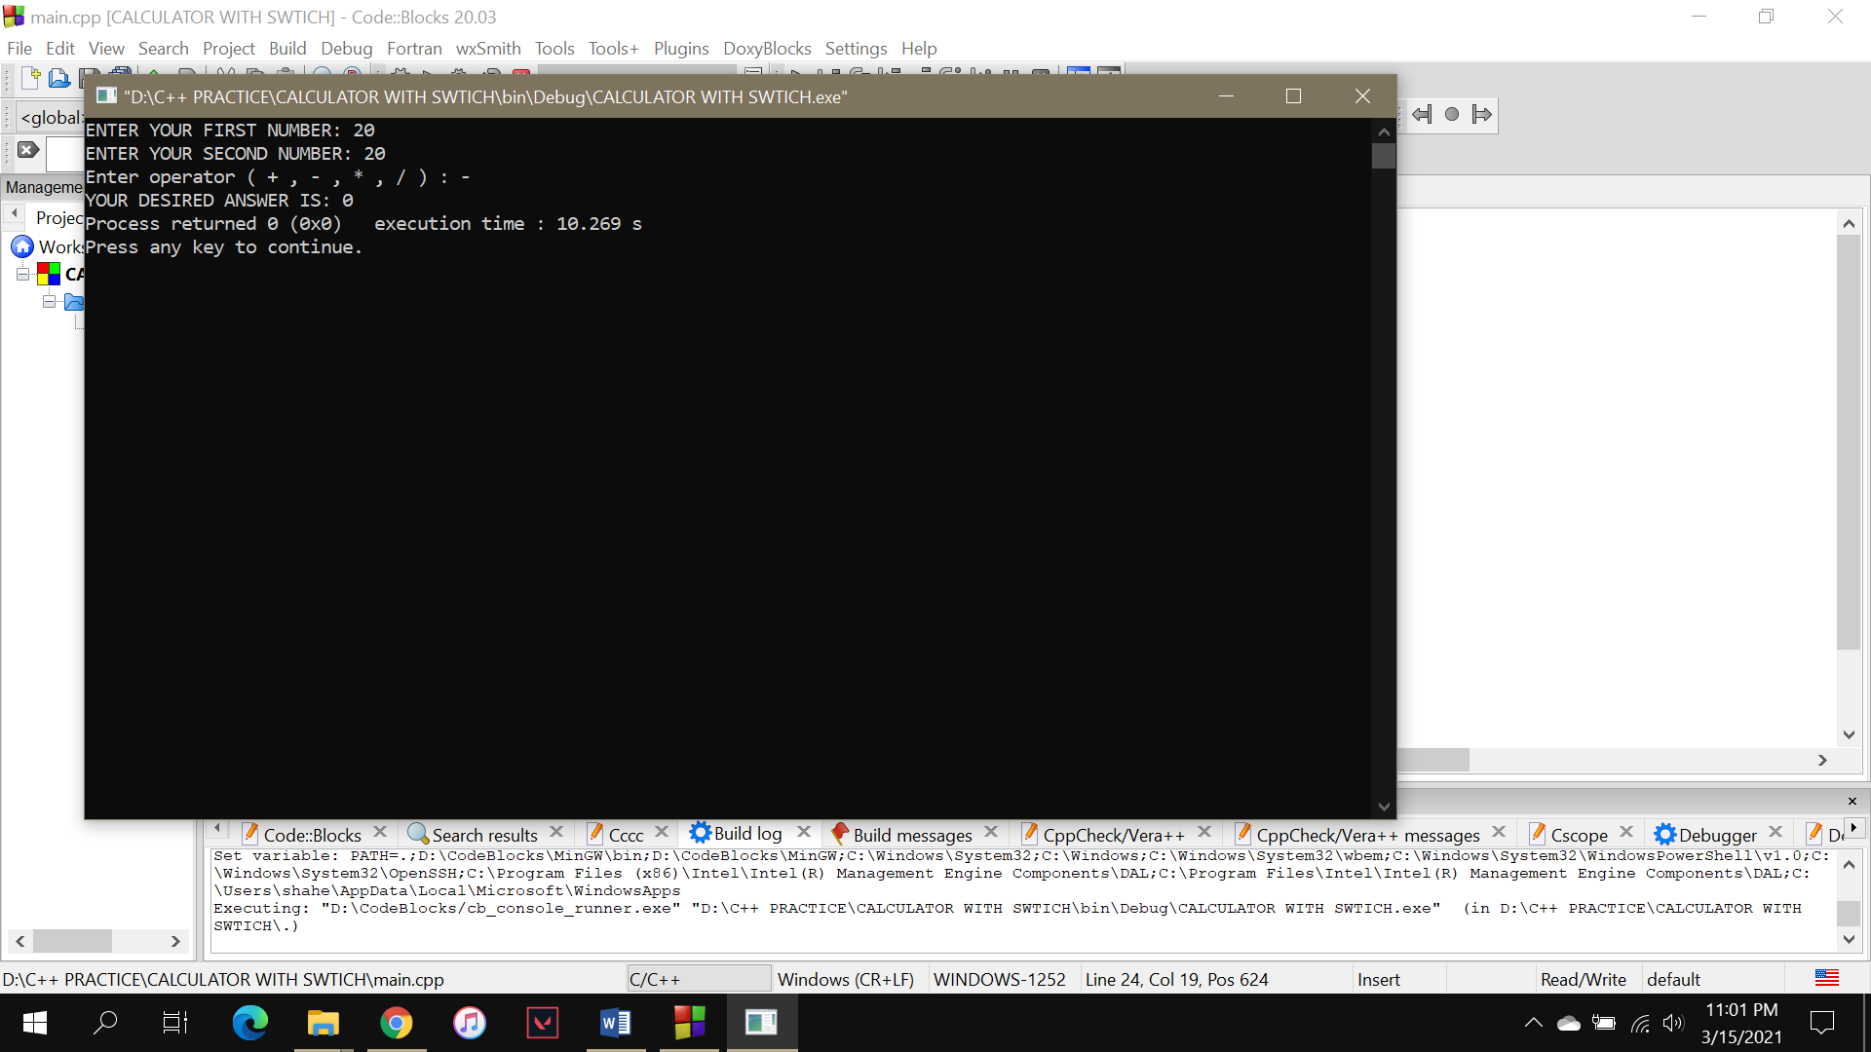

OUTPUT (\*)

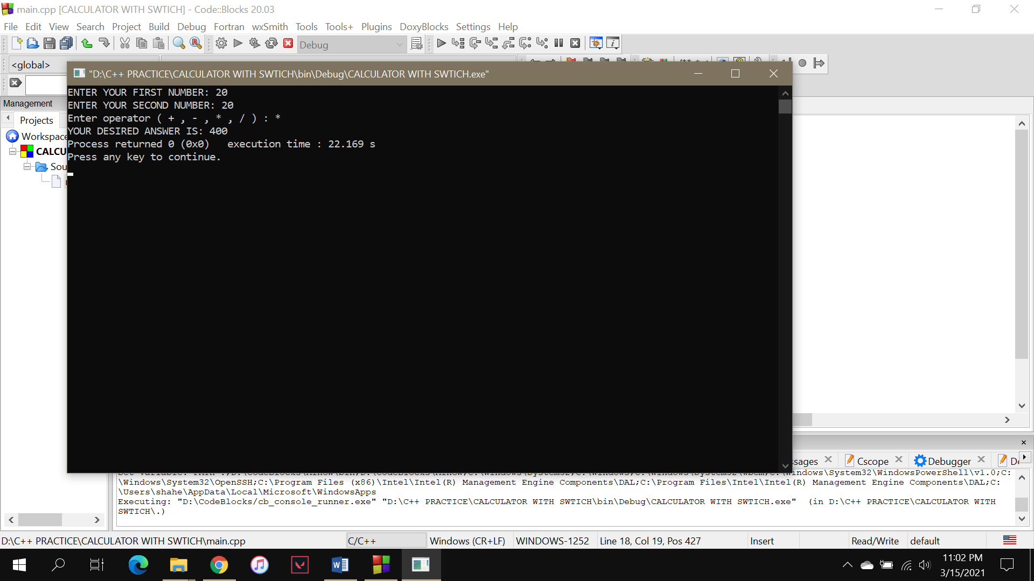

OUTPUT (/)

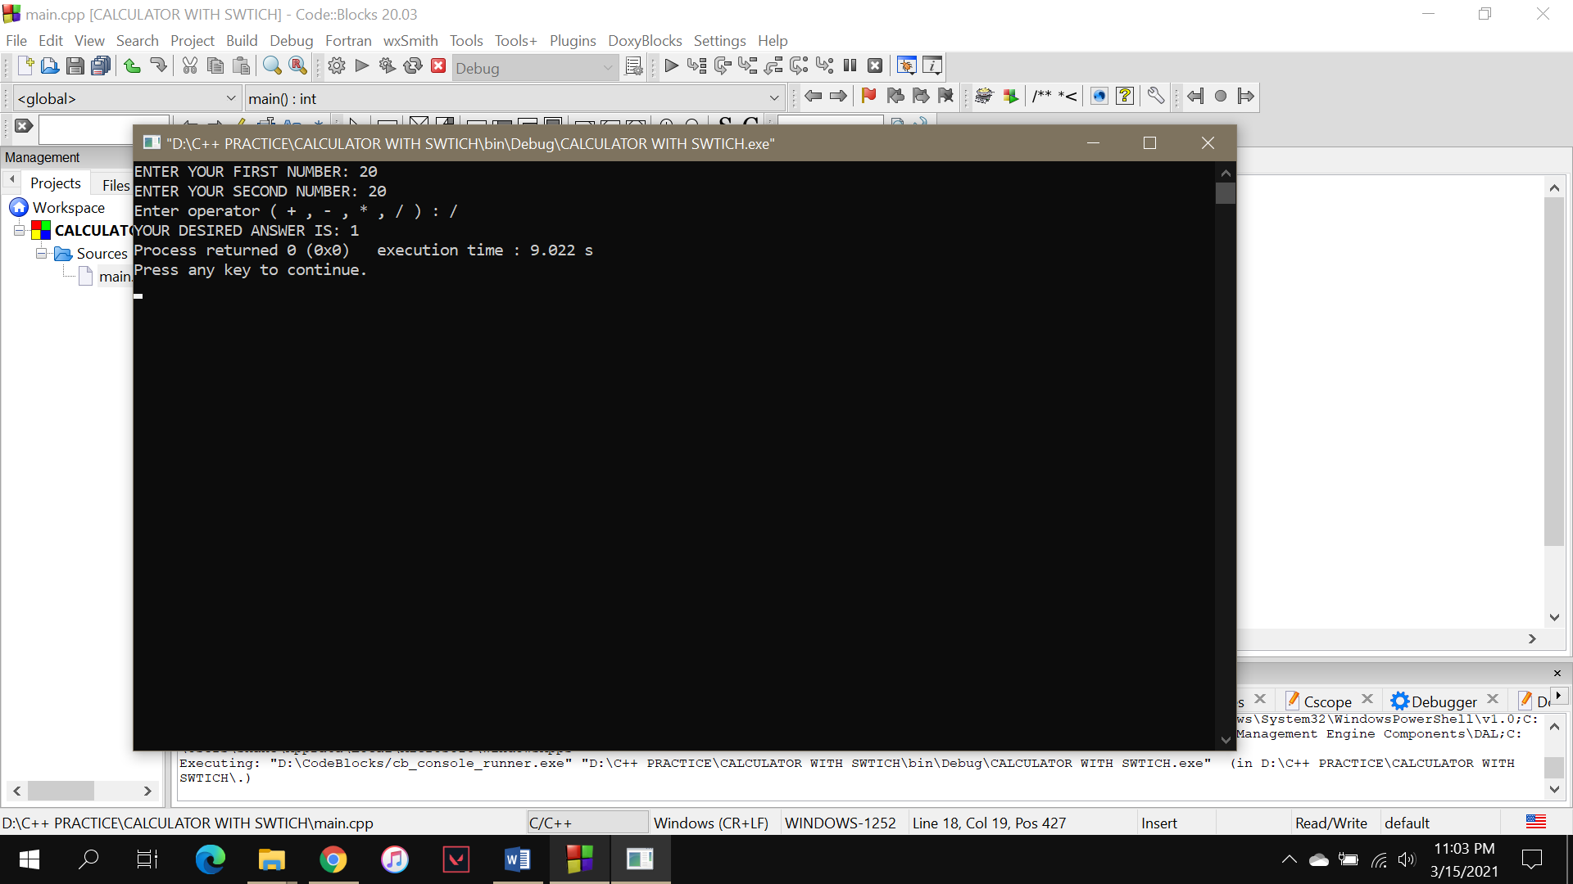

In case user enters a wrong operator.

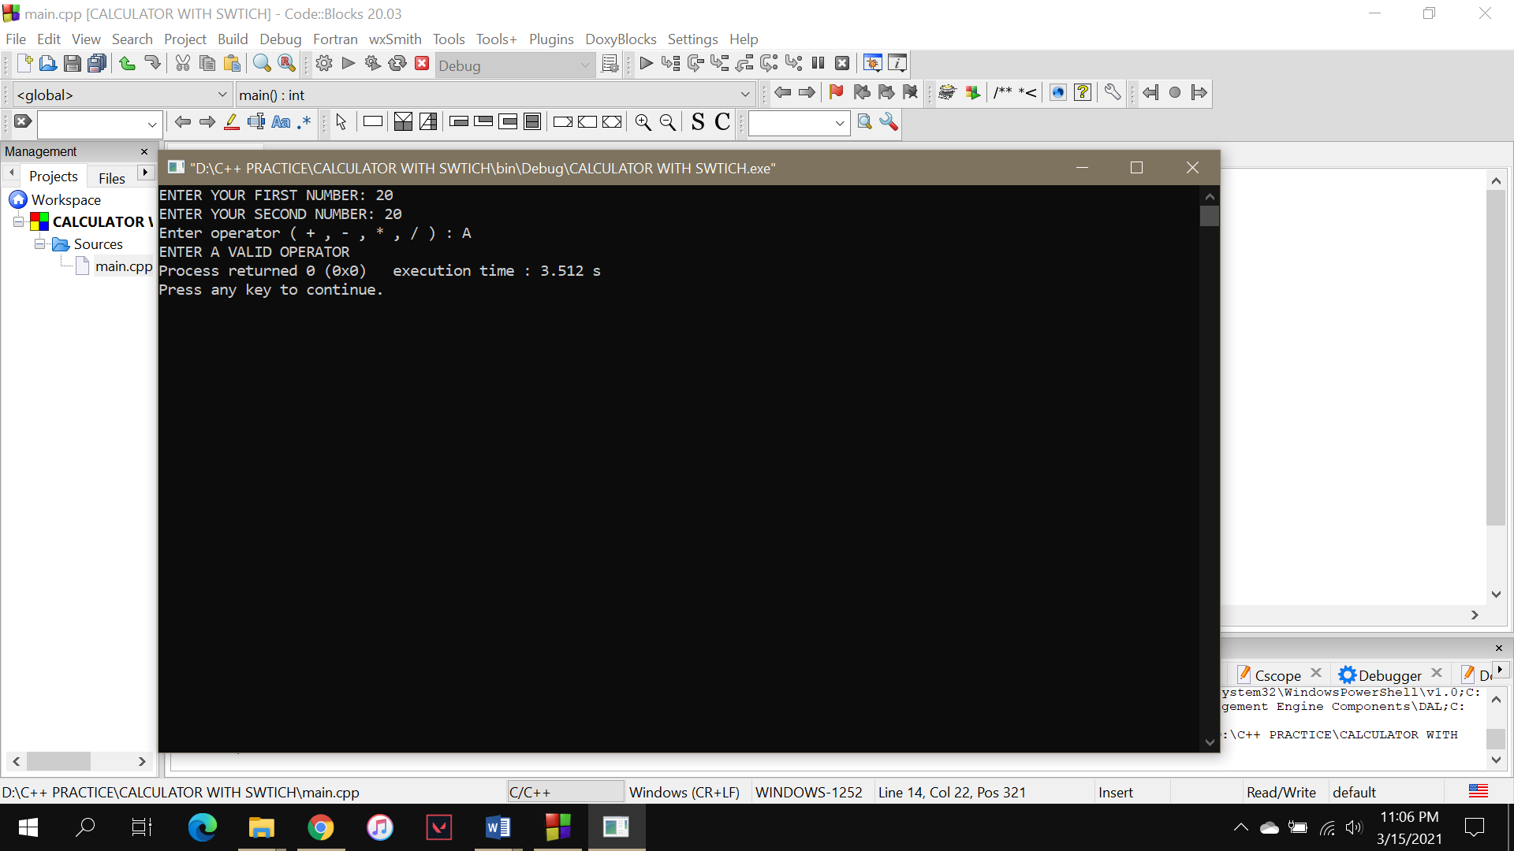

CALCULATOR USING CONDITIONAL STATEMENTS

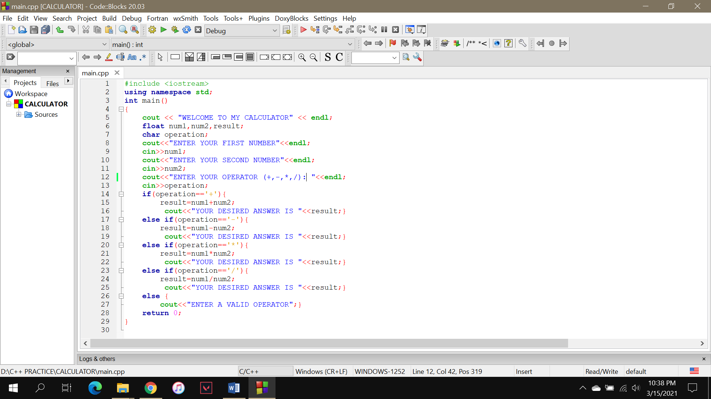

OUTPUT (+)

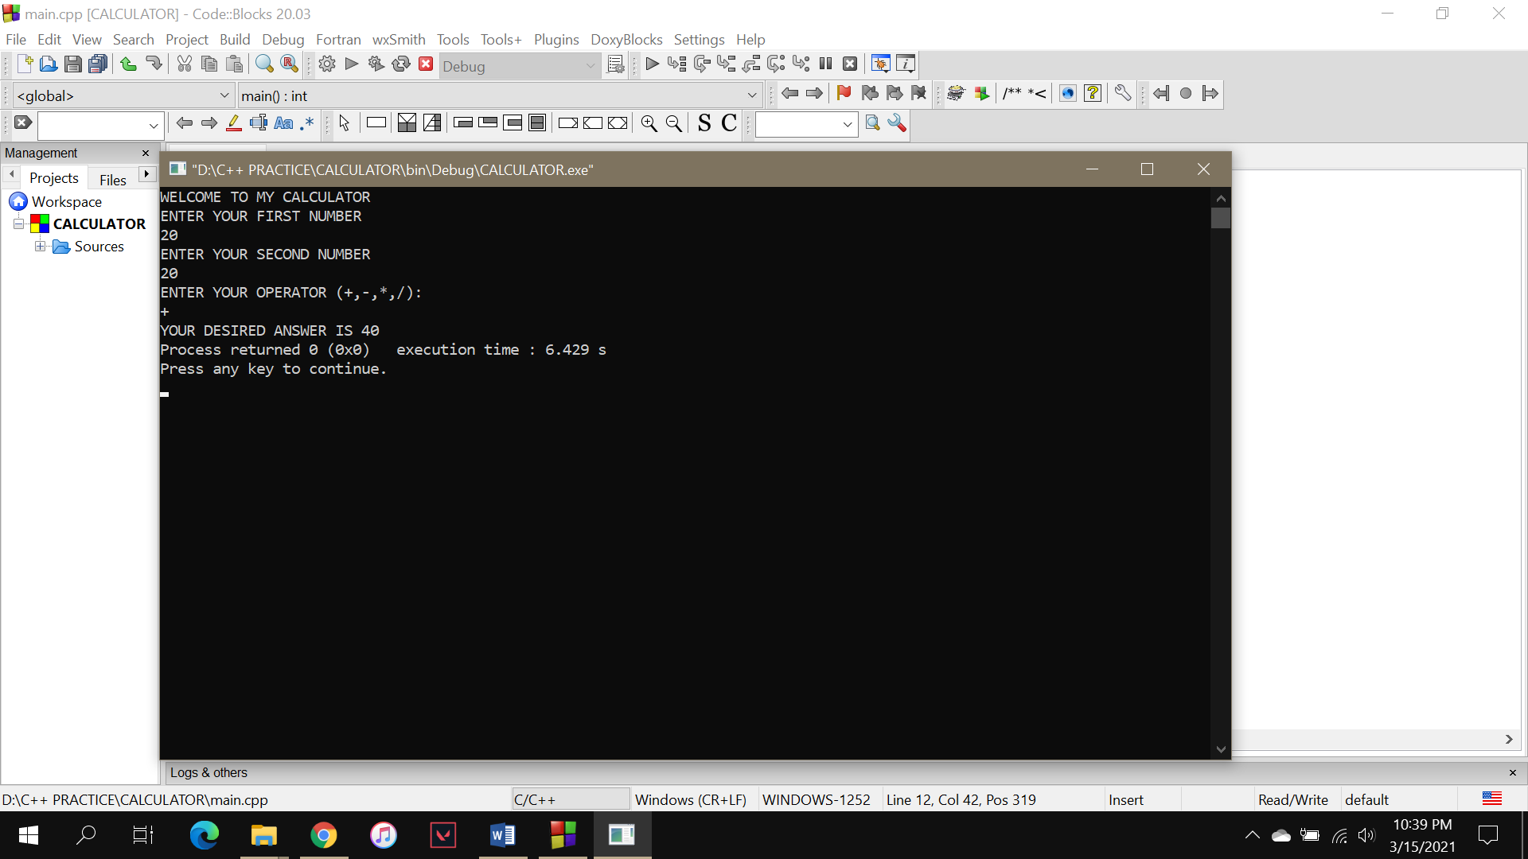

OUTPUT (-)



OUTPUT (\*)

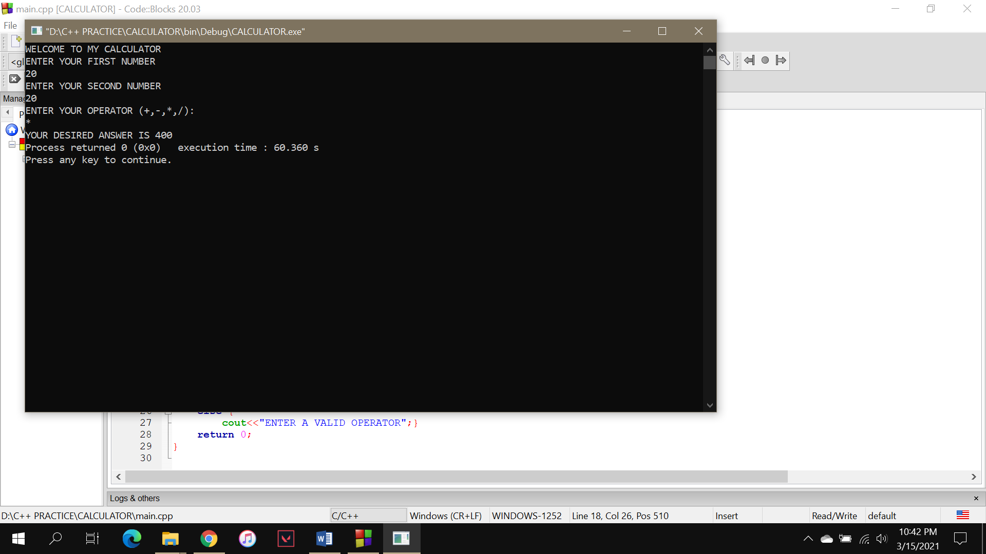

OUTPUT (/)

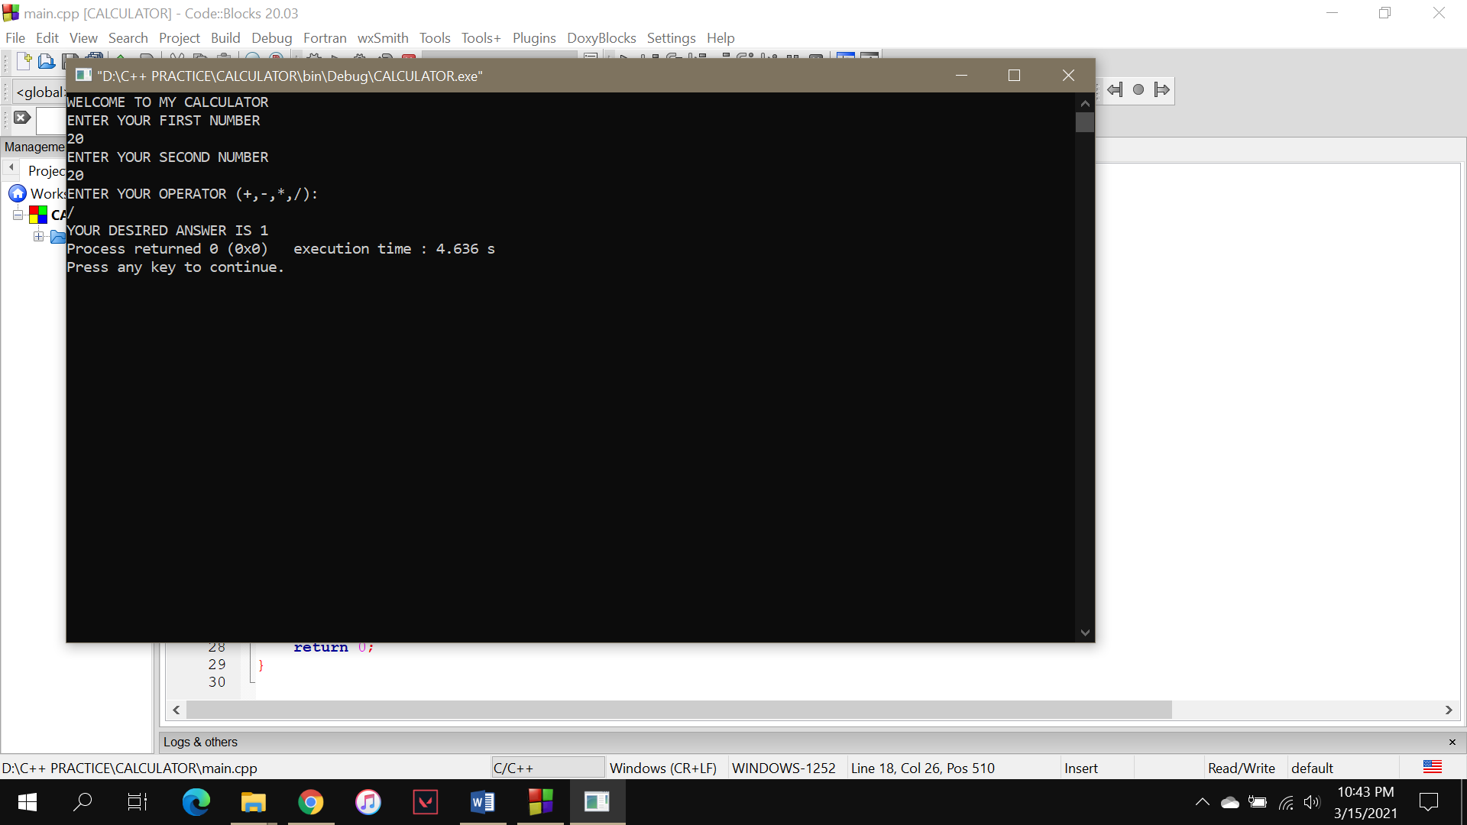

In case user enters a wrong operator.

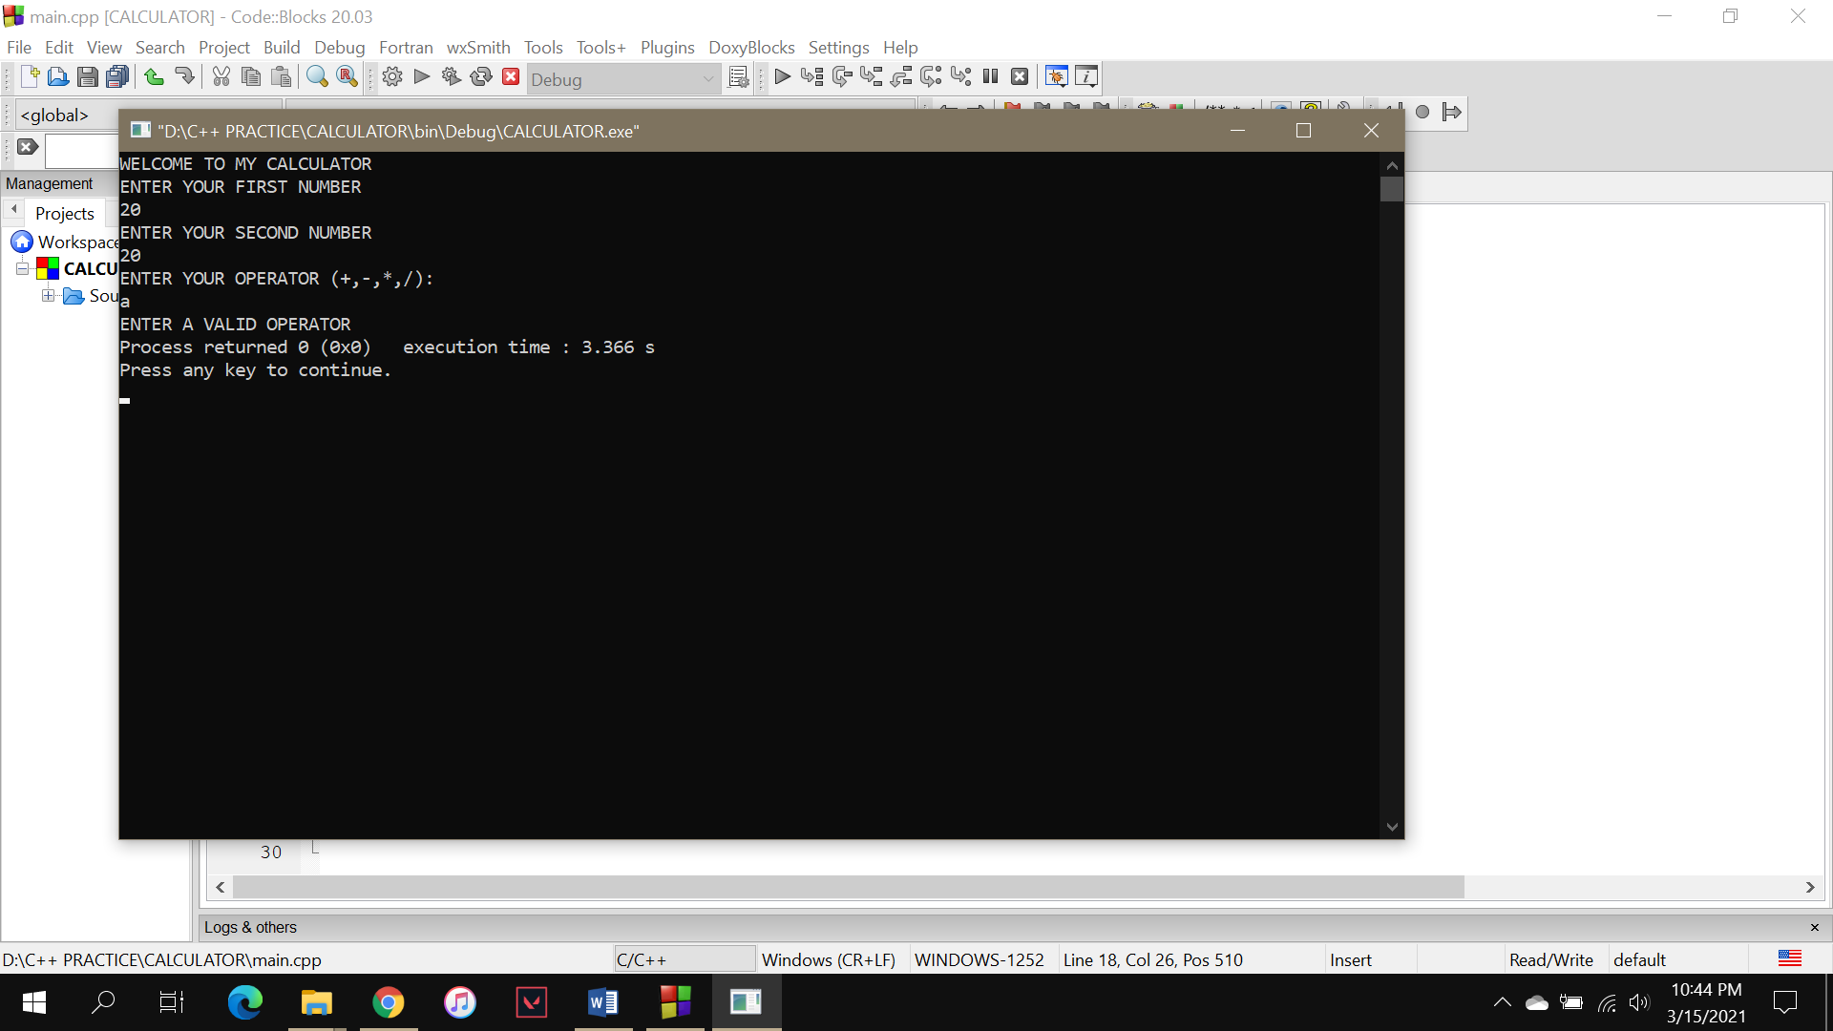

SUM OF EVEN NUMBERS FROM 1-100 USING DO -WHILE LOOP

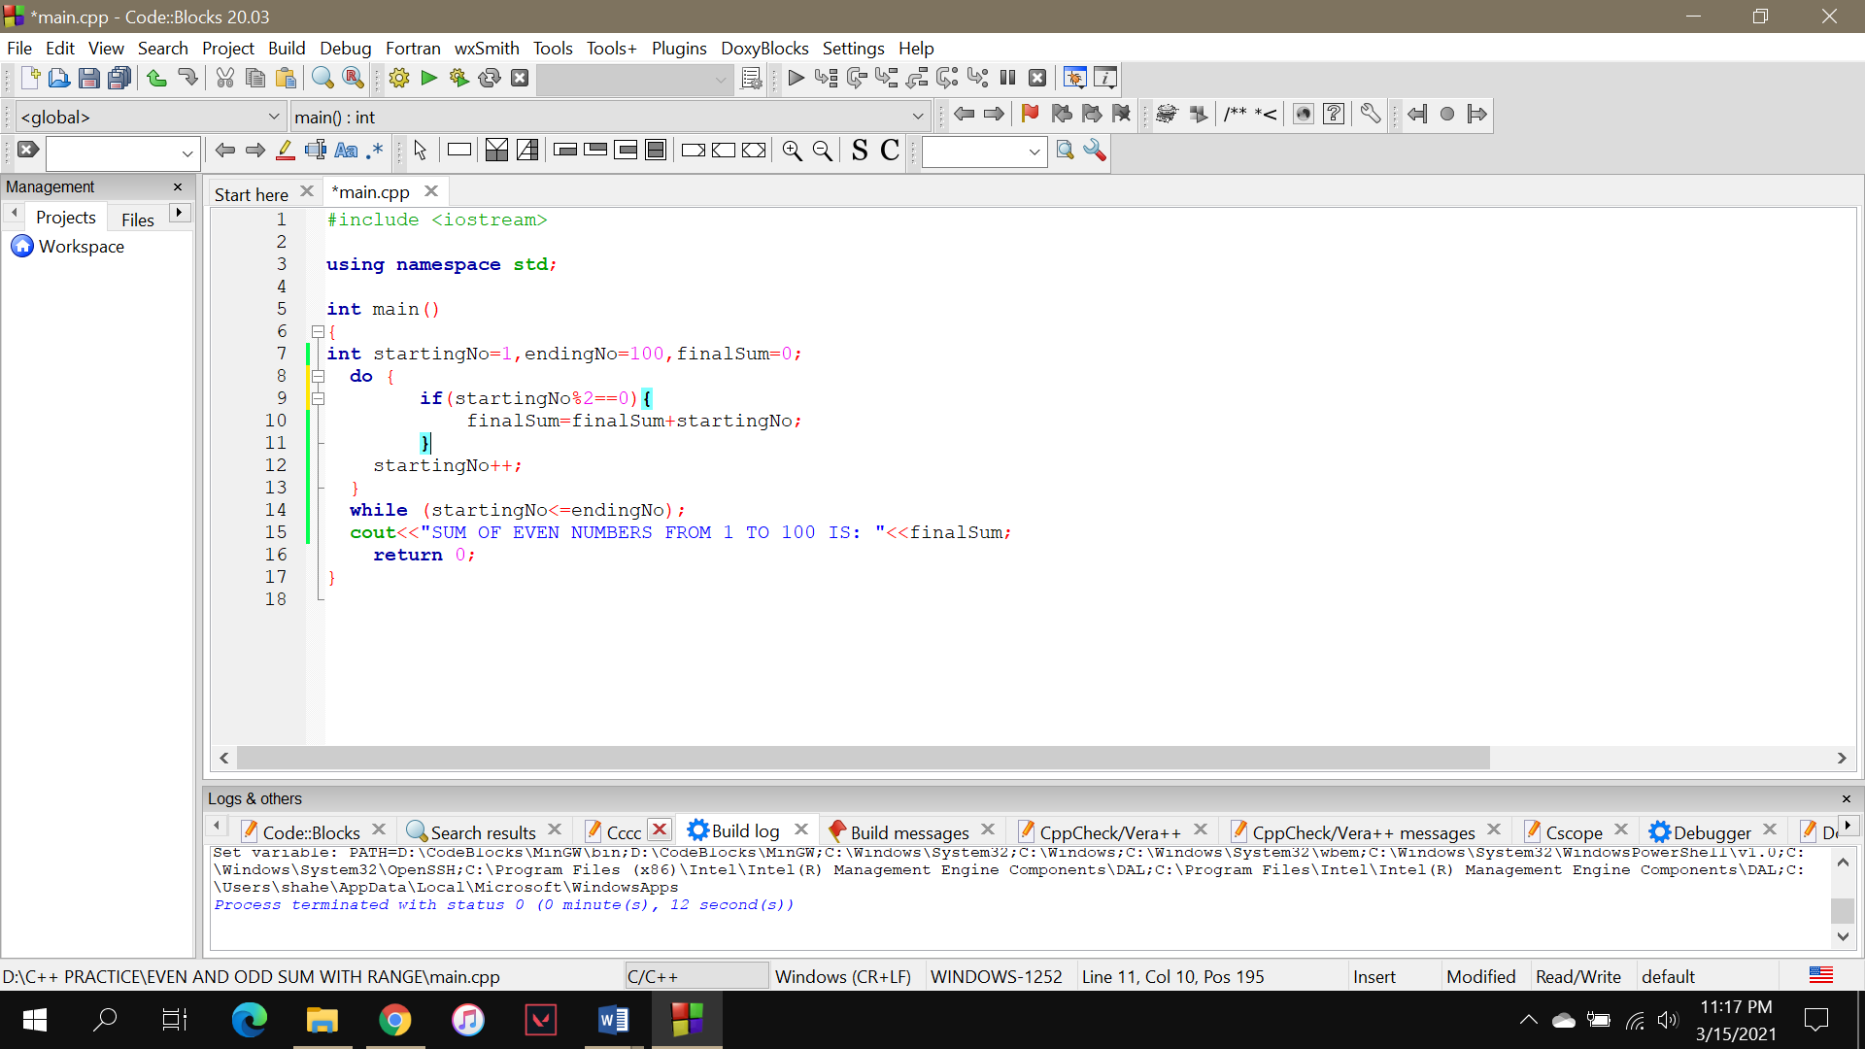

OUTPUT

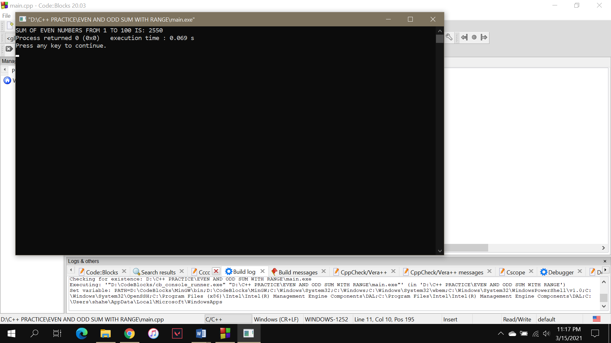

SUM OF ODD NUMBERS FROM 1-100 USING WHILE LOOP

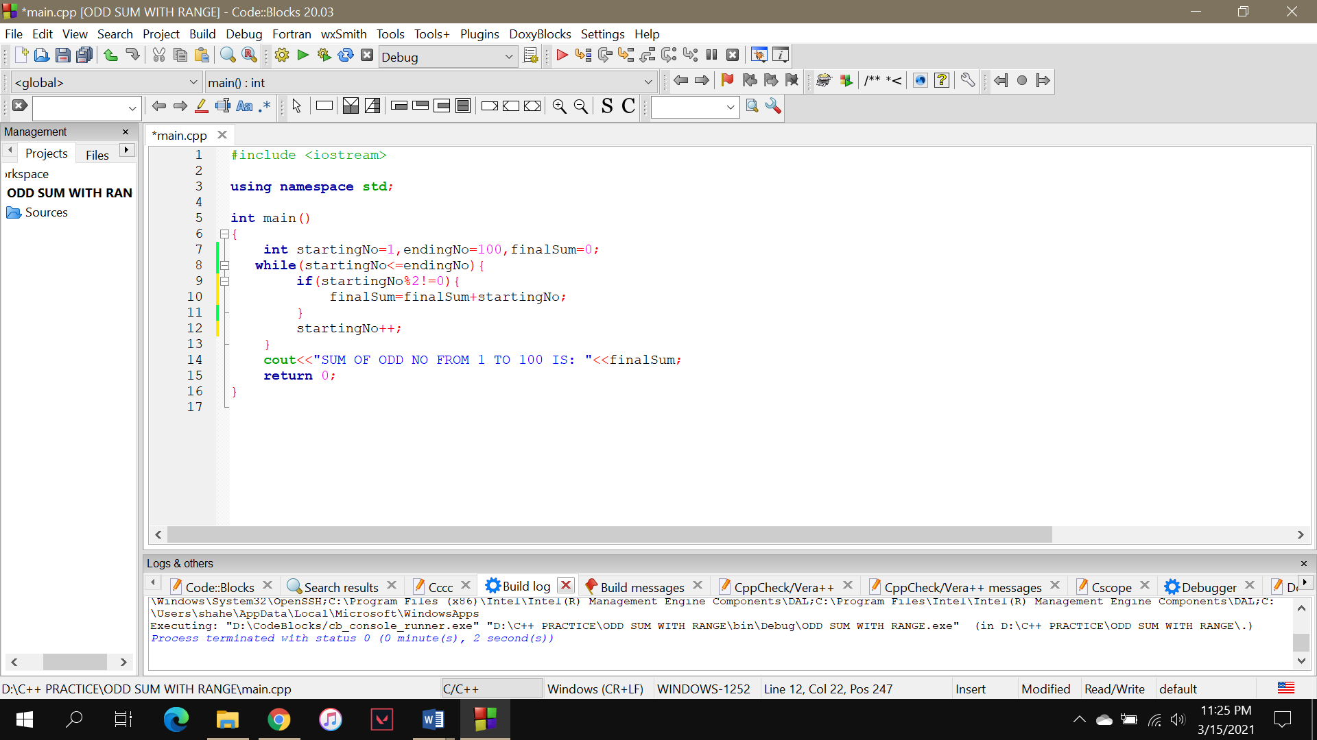

OUTPUT

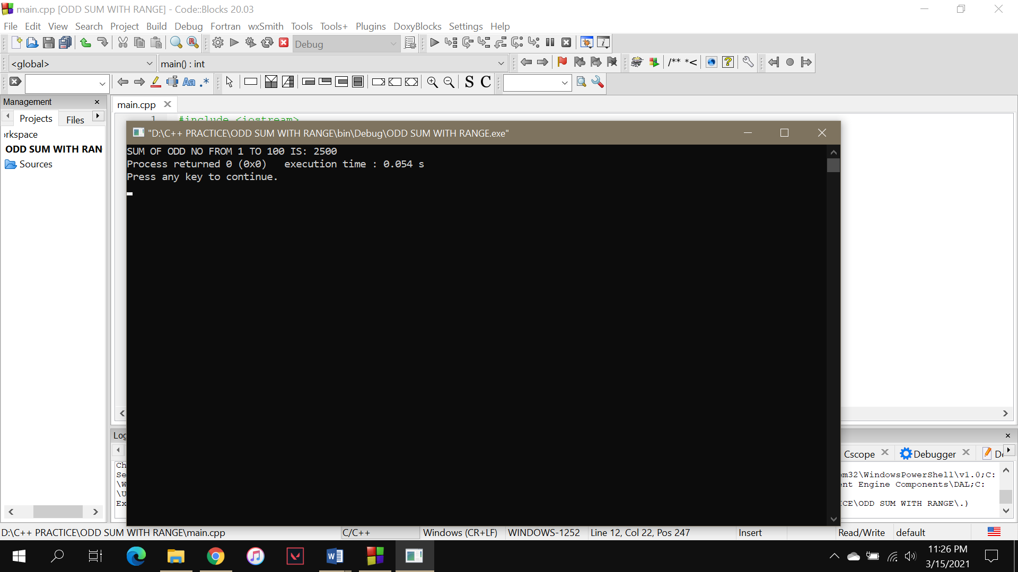

TABLE WITH RANGE USING FOR LOOP

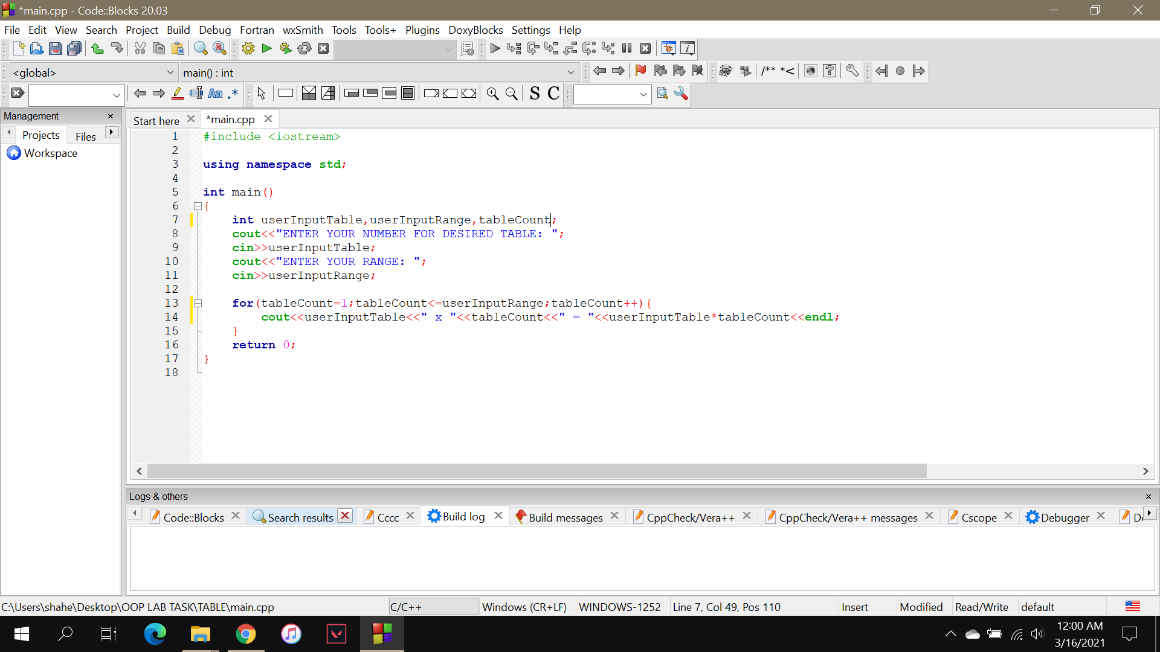

OUTPUT

